Cassina LC3 Armchair 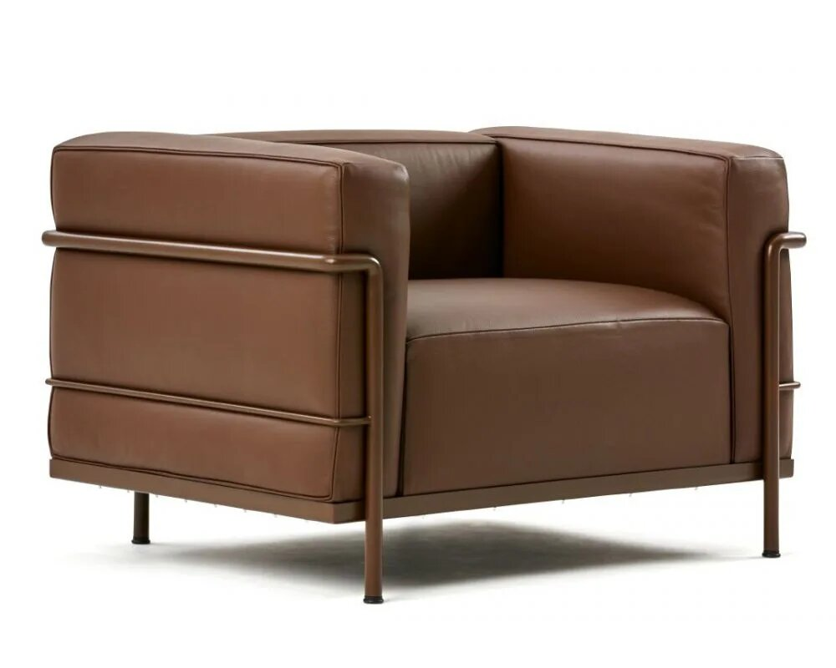

Also designed by Le Corbusier, Pierre Jeanneret, and Charlotte Perriand, this chair has a similar style to the LC2 but features larger cushions and a more relaxed posture.